OOPs Concept Assignment: Simple Notification System:

Source code GitHub url: https://github.com/Padmavathi-SJ/Presidio-training/tree/main/04-05-2026/notifySystem

Output:
Outputs console statements in terminal
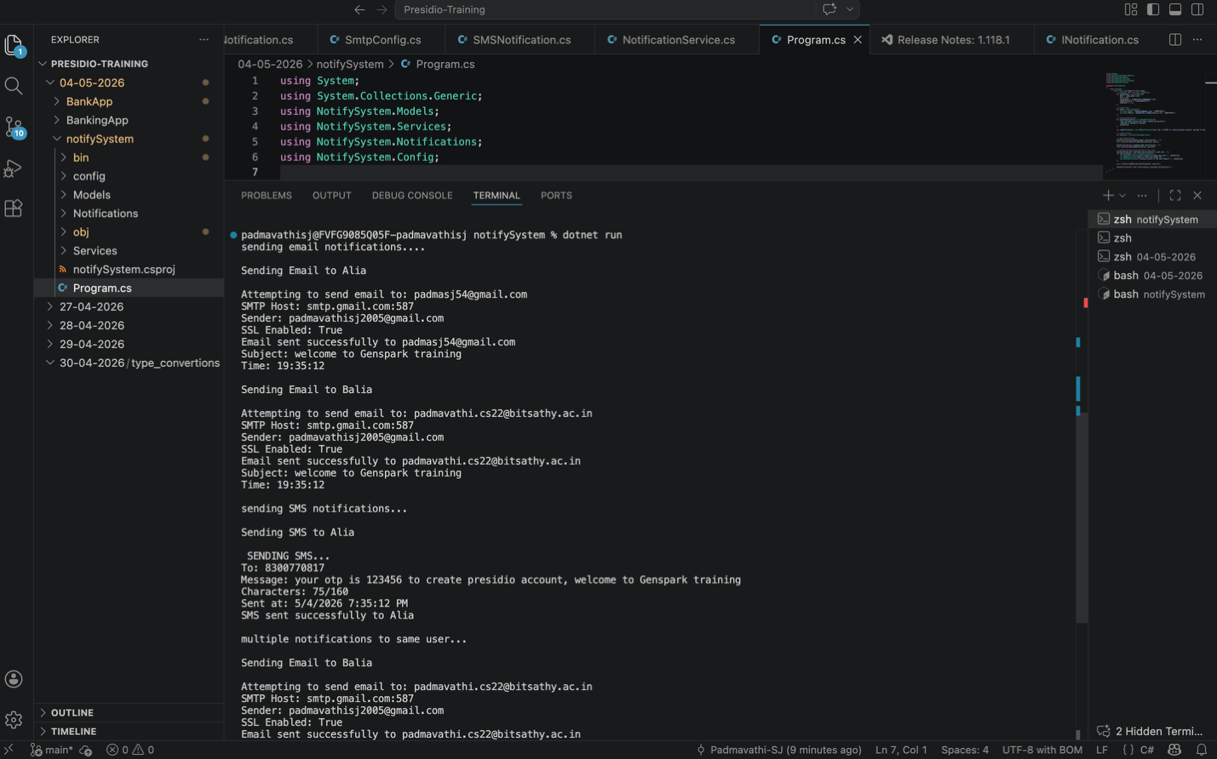

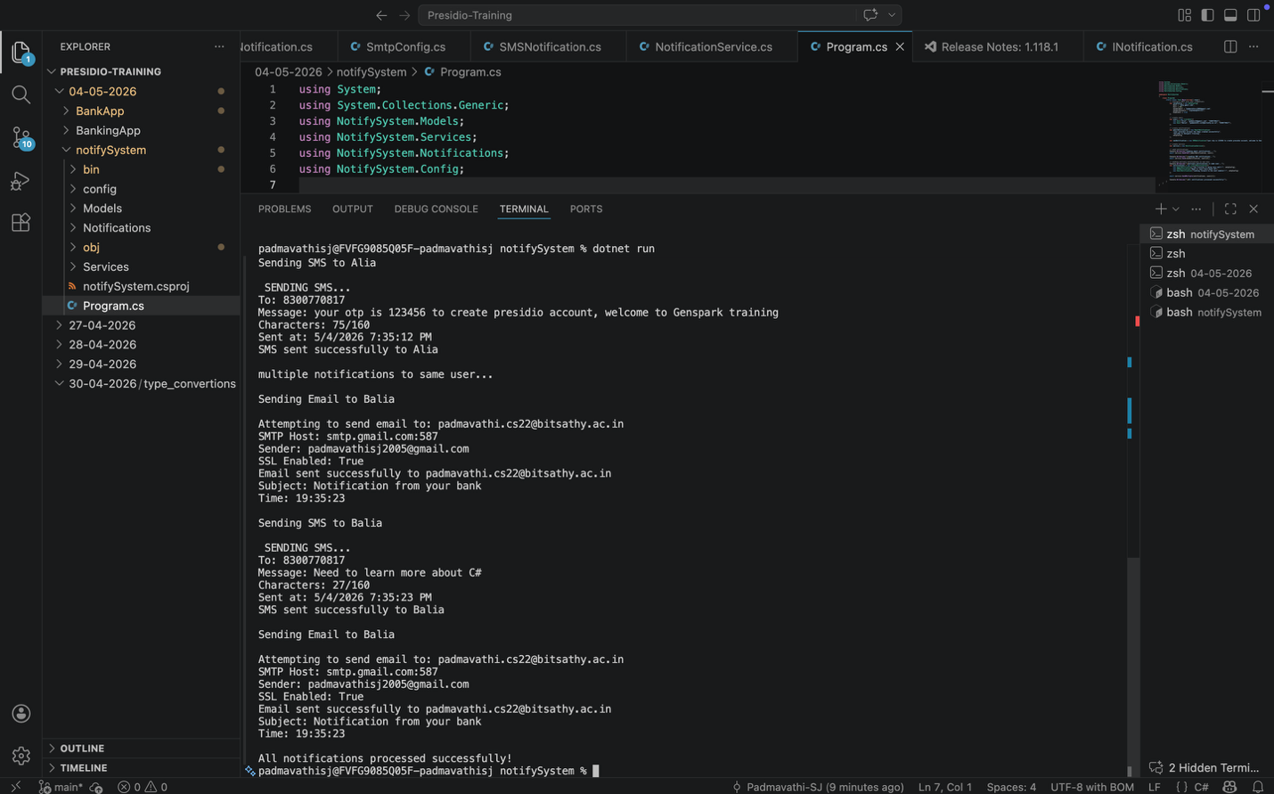

Proof: notification received to the given email id of user.
